Payman’s desktop screenshots
Bubble sort has been coded as a function and call and run it for different dataset sizes
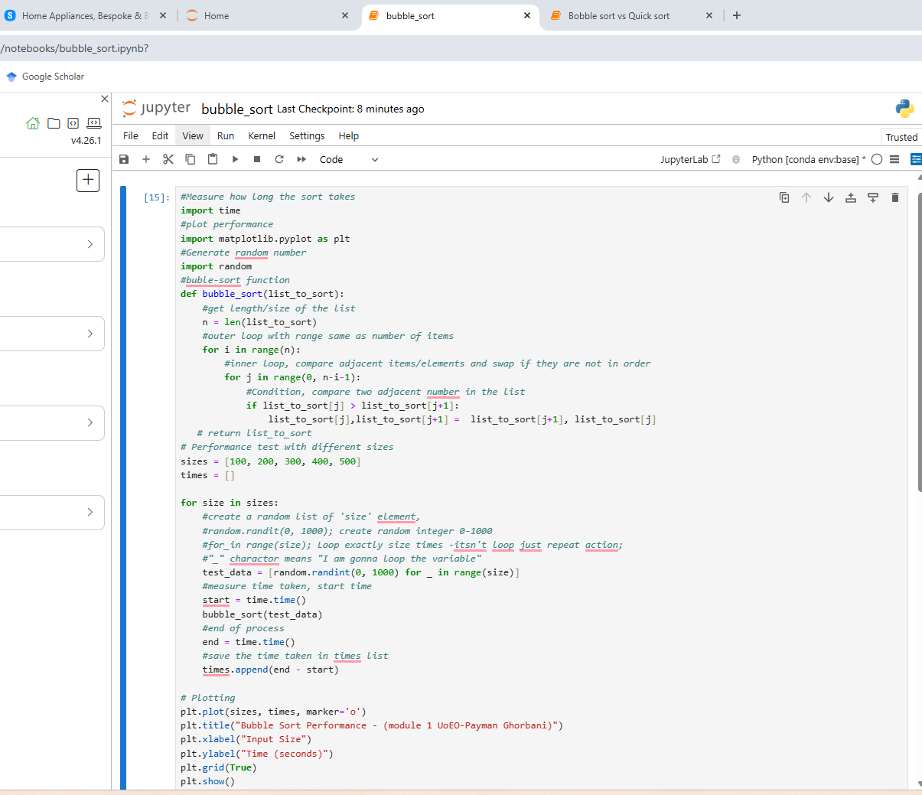
Plotting the Performance of Bubble Sort
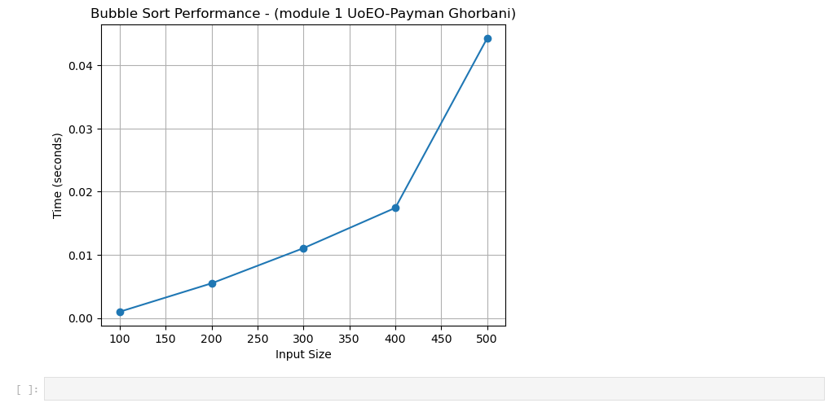
Bubble Sort vs. Quick sort
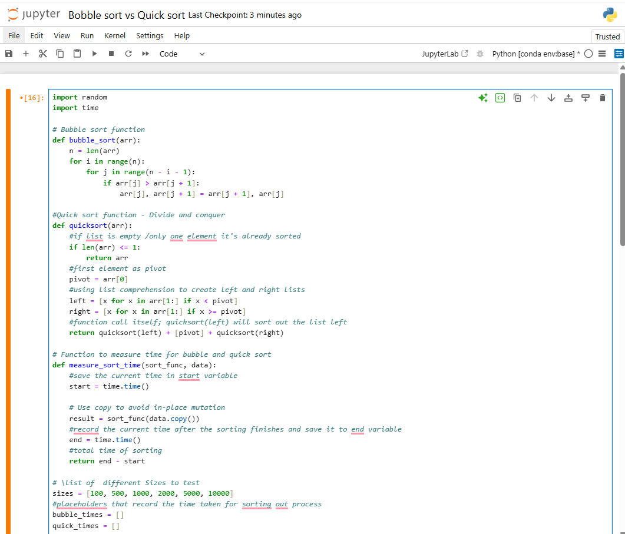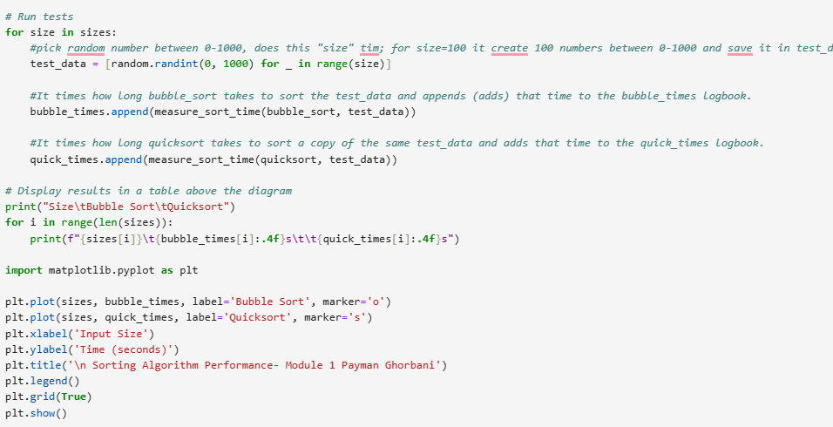

Plotting Bubble Sort VS. Quick Sort
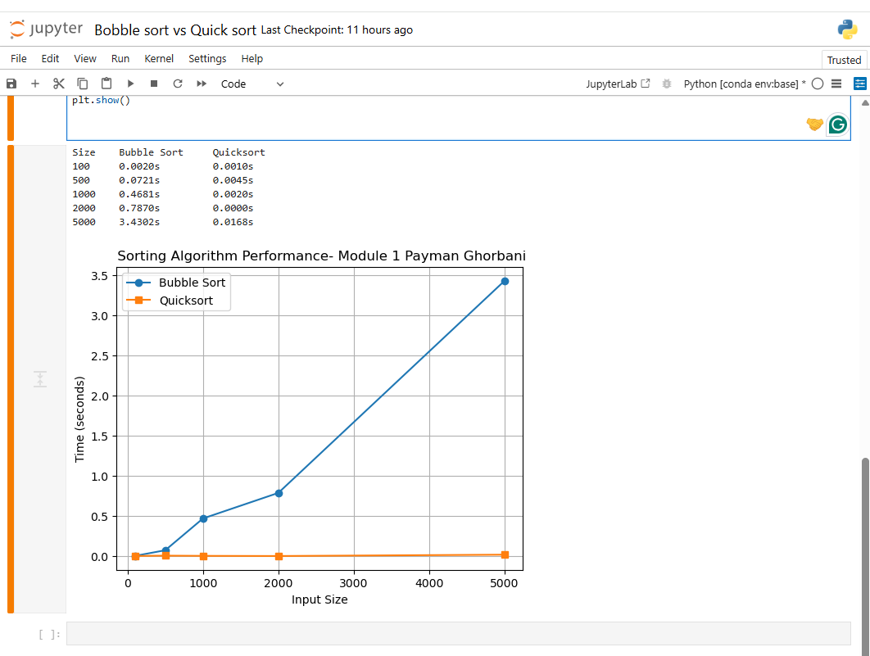
Increasing the dataset sizes to 10000
